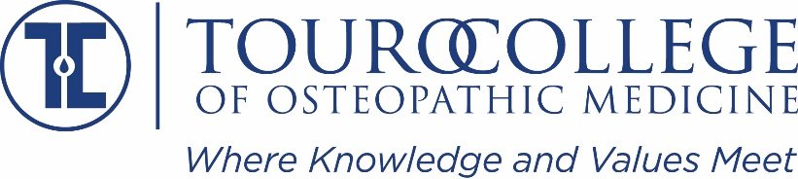

Basic Biomedical Sciences Faculty Position
Middletown, NY Campus

Department: Basic Biomedical Science | Status: Fulltime
Reports To: Associate Chair, Department of Basic Biomedical Science | FLSA: Exempt
Supervises: N/A | Revised:

About the Touro College and University System
Touro is a system of non-profit institutions of higher and professional education. Touro College was chartered in 1970 primarily to enrich the Jewish heritage, and to serve the larger American and global community. Approximately 18,000 students are currently enrolled in its various schools and divisions, including 16 under-graduate, 12 graduate and seven professional schools. Touro College has 29 campuses, locations and instructional sites in the New York area, as well as branch campuses and programs in Berlin, Jerusalem, Moscow, Paris and Florida. New York Medical College, Touro University California and its Nevada branch campus, as well as Touro University Worldwide and its Touro College Los Angeles division are separately accredited institutions within the Touro College and University System. For further information on Touro College, please go to: http://www.touro.edu
The Touro College of Osteopathic Medicine (TouroCOM) opened on 125th in Harlem in 2007 with a mission that emphasizes the practice of medicine in underserved communities. In 2014 the TouroCOM Middletown, NY campus was established to help serve medical needs of the Hudson Valley. The TouroCOM Middletown campus includes state-of-the-art classrooms, clinical training facilities, medical simulation Lab, and student dorm rooms. TouroCOM faculty use an innovative “flipped” classroom approach to deliver a curriculum that emphasizes clinical application in an active classroom setting, peer-peer learning, and formative assessment as part of the learning process.

Job Summary:
The Department of Basic Biomedical Science at the Touro College of Osteopathic Medicine (TouroCOM) seeks to fill a 12-month, full-time faculty position in Medical Biochemistry/Genetics at its Middletown, NY campus. The most qualified candidate for this position will meet the qualifications for Associate Professor or higher and serve as Course Director for the Medical Biochemistry course.

Job Responsibilities
The faculty position specifically involves collaborating with faculty on the Harlem campus in the development, organization, and delivery of the Medical Biochemistry/Genetics curriculum presented simultaneously on both campuses. The successful candidate is expected to teach using a combination of live and recorded sessions applied in the flipped classroom format and provide timely feedback on student learning using innovative formative and summative assessments. If appointed, Course Director duties include oversight of the delivery of the Medical Biochemistry course on the Middletown campus.

Although a commitment to excellence in teaching is the primary responsibility of the position, faculty members also provide service to the school in a variety of ways including conducting student interviews, serving as students advisors, and participating on the administrative committees of the college. The successful candidate is expected to already have, or to develop scholarly activity that results in peer-reviewed publications.

Requirements

Education, Preparation, and Training

Applicants must have a D.O. or M.D. degree, or a Ph.D. in Biochemistry or related discipline. The successful candidate will demonstrate the potential for exceptional teaching at the medical school or graduate level in the areas mentioned in the job responsibilities section, demonstrate potential for research, and work well with the rest of faculty team.

Skills

The ideal candidate will be proficient in the following areas: teaching, relevant content expertise, research techniques, instructional design, delivery and assessment, course management, public speaking, effective communication, working independently and as part of a team, organizational skills.

Physical Demands
Extensive use of computers

Computer Skills

Basic computer skills supporting the proficient use of the Microsoft Office Suite, software used to prepare and administer exams electronically, and learning management systems.

Travel

Infrequent travel to the branch campus location in Manhattan, NY. Travel to professional academic conferences, as approved by the Department Chair

Qualifications:

To perform this job successfully, an individual must be able to perform each essential function satisfactorily. The requirements listed above are representative of the knowledge, skill and/or ability required. Reasonable accommodation may be made to enable individuals with disabilities to perform the essential duties.

To Apply:
Inquiries related to the position can be sent to: david.manna@touro.edu. To apply, please submit a cover letter and CV (MS Word or PDF) with contact information for three references to Jodi.Shepard-Cheatham@touro.edu. Please include a history of teaching experience and a concise statement of your teaching and research goals. Qualified applicants will be invited for an on-site interview, which will include a teaching demonstration. The start date for the position is February 2021. Salary will be commensurate with experience. A comprehensive benefits package is also included for full-time positions. For more information, visit http://tourocom.touro.edu/.
Touro College is committed to the principles of equal employment opportunity. Our practices and employment decisions regarding employment, hiring, assignment, promotion, compensation, and other terms and conditions of employment are not based on an employee's race, color, sex, age, religion, national origin, disability, ancestry, military discharge status, sexual orientation, marital status, genetic predisposition, housing status, or any other protected status, in accordance with applicable law. Our policies are in conformance with Title IX, 1972 Education Amendments.

